

**TOPICE: - MIND CRUSHER**

**NAME**: -AMBER KUMAR SINGH

**CLASS**: -XII **SEC**: -A

**ROLL NO.**: -02

**SESSION**: -2020-21

**SUBMITTED TO: -** Mr. ANSHUMAN SIR

* ABOUT THE PROJECT
* SYSTEM REQUIREMENTS
* LIMITATION OF SOFTWARE
* DEVELOPMENT PLATFORM USED
* MINIMUM PLATFORM REQUIREMENT
* FILE STRUCTURE
* FUNCTION USED
* DATA STRUCTURE
* MODULE STRUCTURE
* CODING
* INPUT-OUTPUT SCREENSHOT
* USUAL MANUAL
* DECLARATION
* BIBLIOGRAPHY

CERTIFICATE

This is certify that

AMBER KUMAR SINGH

Of Class XII ‘A’, Roll No. -_ _ _ _ _ _ _  
 Session – 2020-21 , has worked on the  
Project “**MIND CRUSHER**”  
 under the guidance of Mr.Anshuman sir  
 and successfully completed it.

DATE:-_ _ _ _ _ _ _

_______________

Internal examiner

______________

Examiner”s Sign

___________________

Sign Of Principal   
 (KENDRIYA VIDYALAYA CHITTARAJAN)

I hear by declare that the project work entitled “**MIND CRUSHER**”, submitted to Department Of Computer Science in Kendriya Vidyalaya Chittaraja is prepared by me. All the coding is result of my personal efforts. I am also uploaded the code to Github for a soft copy refrence.

**The link is given below ☟** ☞[git@github.com:Amberskumarsingh/C.S-Project_12-Python-Udise-School-Library-Detail.git](mailto:git@github.com:Amberskumarsingh/C.S-Project_12-Python-Udise-School-Library-Detail.git) ☜

 OR



AMBER KUMAR SINGH

CLASS XII “A”

I would like to express a deep sense of thanks & gratitude to may project guide **Mr.Anshuman Sir** for guiding me immensely through the course of the project. He always evinced keep intresent in my work. His constructive advice & constant motivation have been responsible for the successful completion of this project.

My sincere thanks go to **Sh.P.K.Tailor**, Our Principal Sir, for his co-ordination in extending every possible support for the completion of this project.

I also thanks to my parents for this motivation & support.   
 LAST BUT NOT LEAST; I would like to thank all those who had helped directly OR indirectly towards the completion of this project.

AMBER KUMAR SINGH

Class: XII ‘A’

1. Operating System:

* Any version of Windows, between Windows 7 to Windows 10
* Mac OS X 10.11 or higher, 64 bit
* Linux: RHEL 6/7, 64-bit (almost all libraries also work in Ubuntu)

1. x86 64-bit CPU (Intel / AMD architecture)
2. 4 GB RAM
3. 5 GB free disk space
4. Operating System: Windows 10 Pro (Version 20H2)
5. RAM: 4 GB DDR3 (3.89 GB usable)
6. Processor: Intel(R) Pentium(R) CPU G630 @ 2.70GHz 2.70 GHz (x64-based processor)
7. Storage: 465.5 GB

This project is a quiz game, which asks ten MCQ based question to the user, and then calculates and displays the score at the end. The questions, along with its respective options, are saved in a JSON file.

1. json
2. random
3. time
4. os

When the program is run, it displays the main menu of the game, in the Shell window. The main menu has four options, Play Quiz, Instructions, Exit and About Us. When the first option is chosen, the game begins and various questions (stored in the JSON file), are displayed on the screen, along with their four respective options. On choosing the second option in the main menu, the instructions are displayed and the user is returned to the main menu. When the third option is chosen, the program is terminated, and a message is displayed. On choosing the About Us option, the About Us message is displayed.

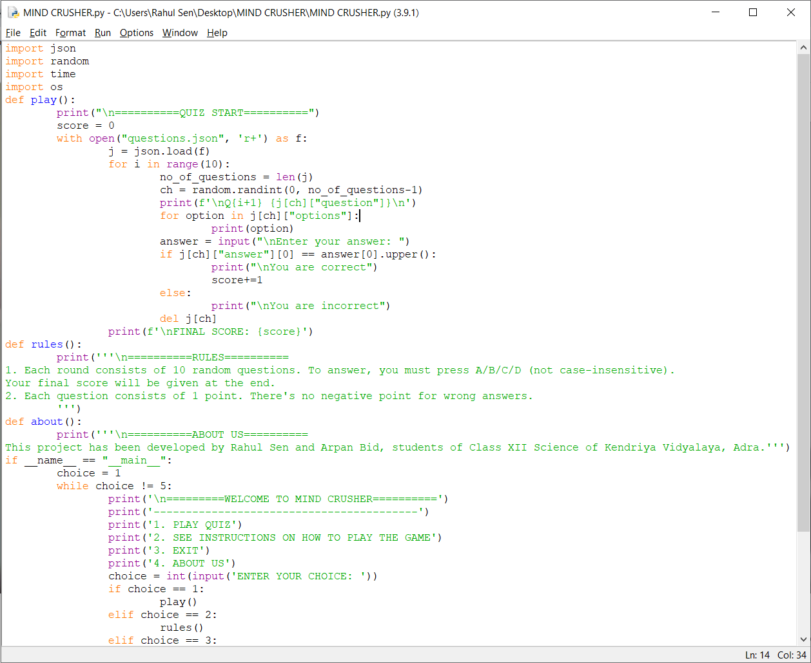

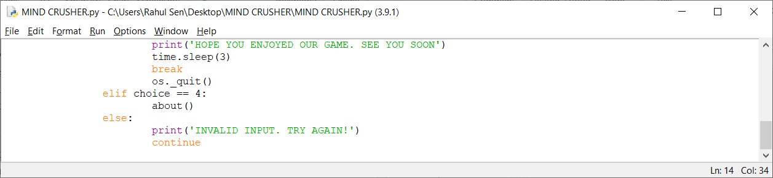

1. Project Folder

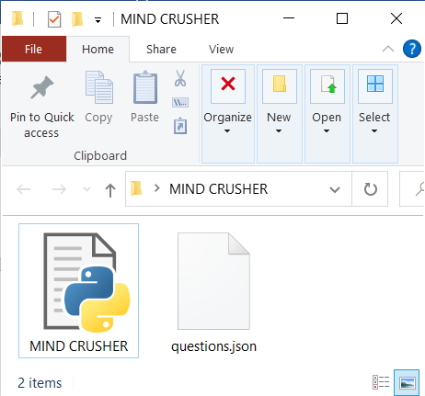

1. json file

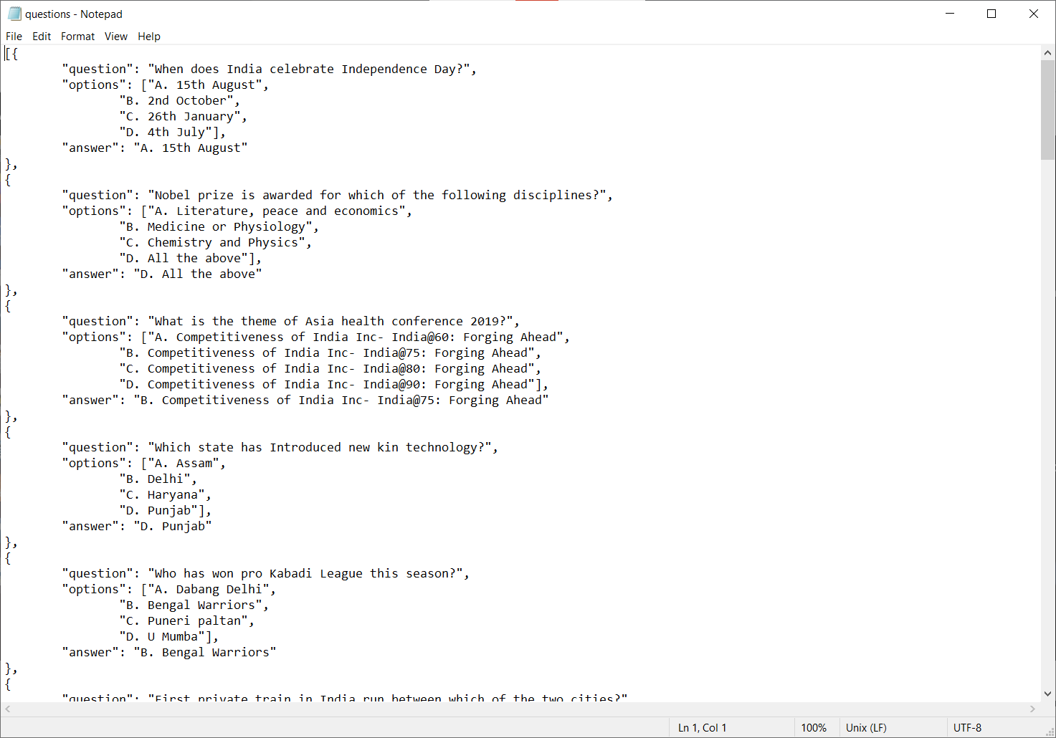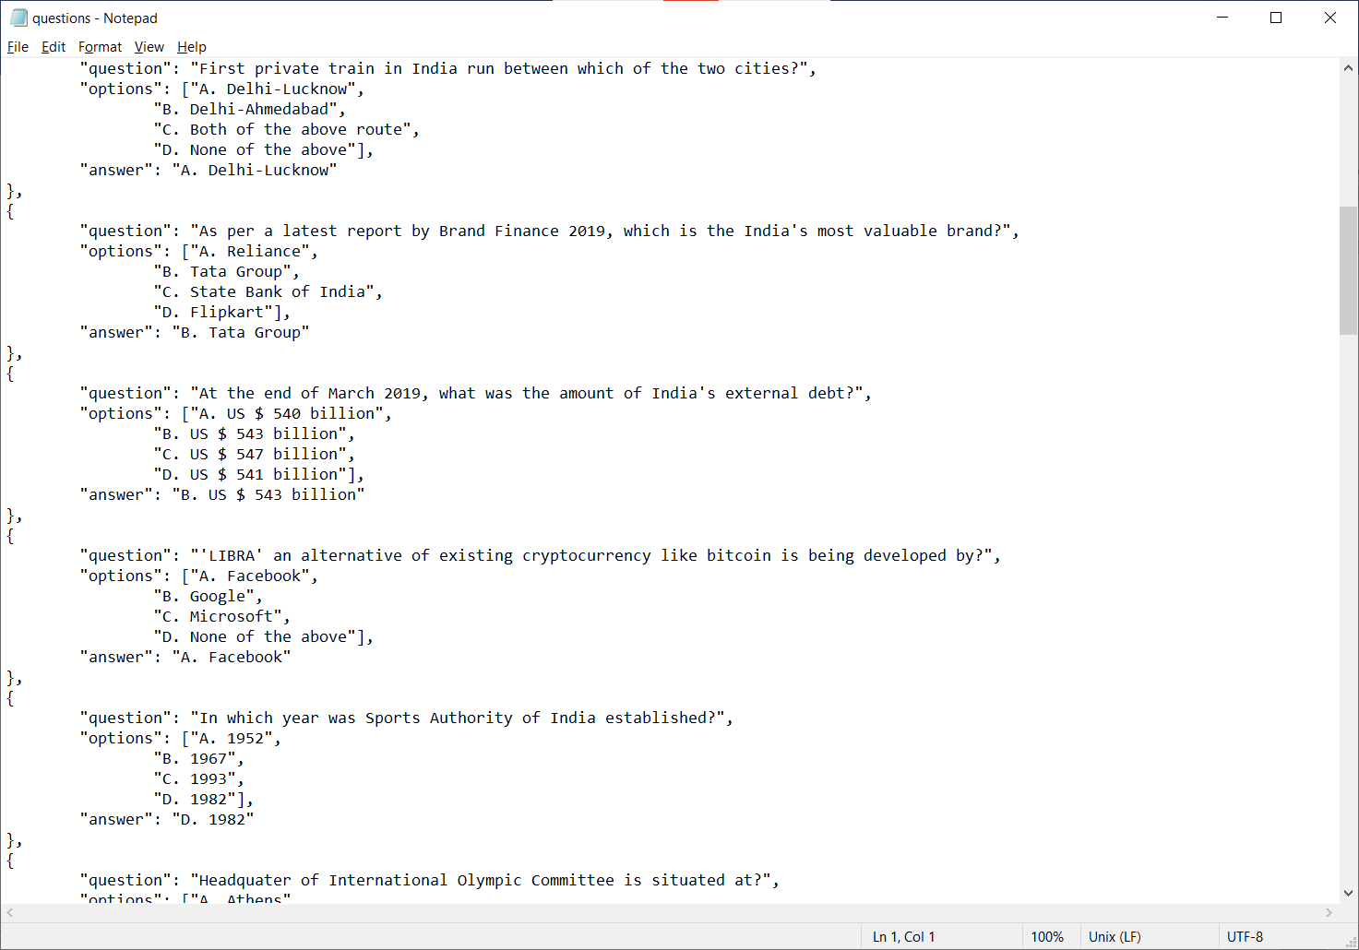

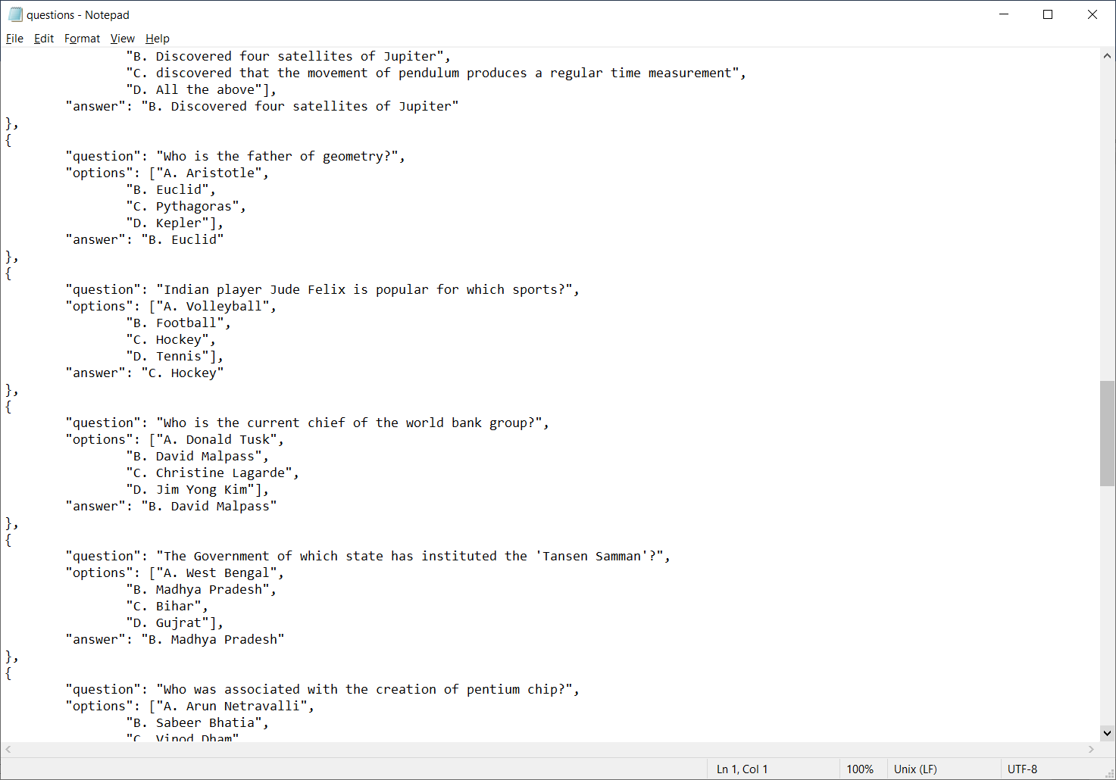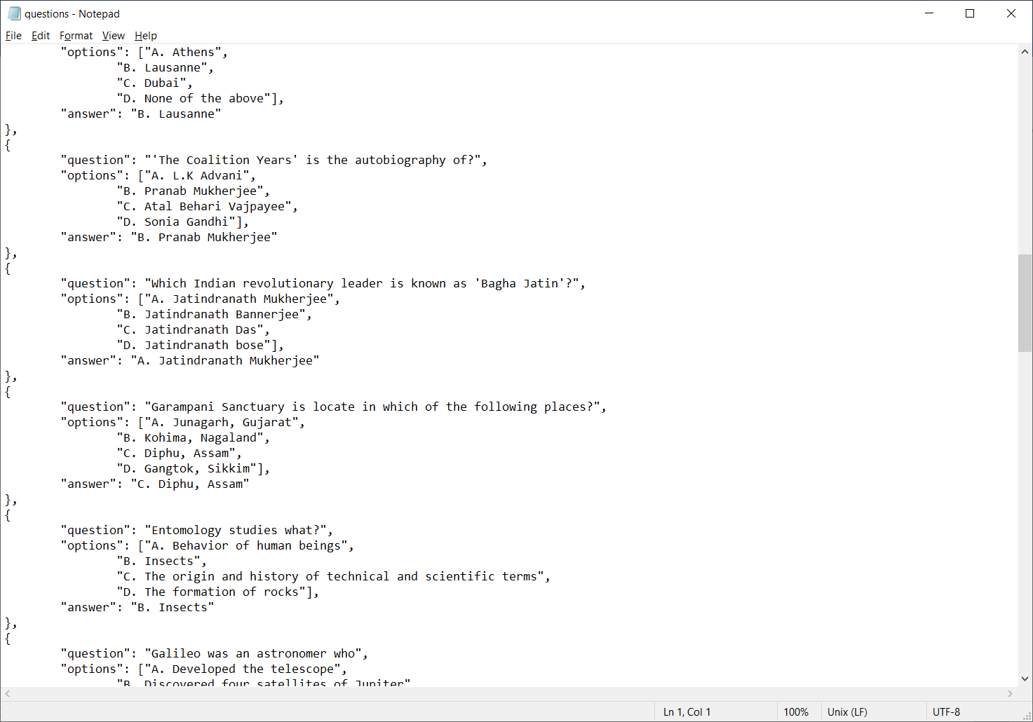

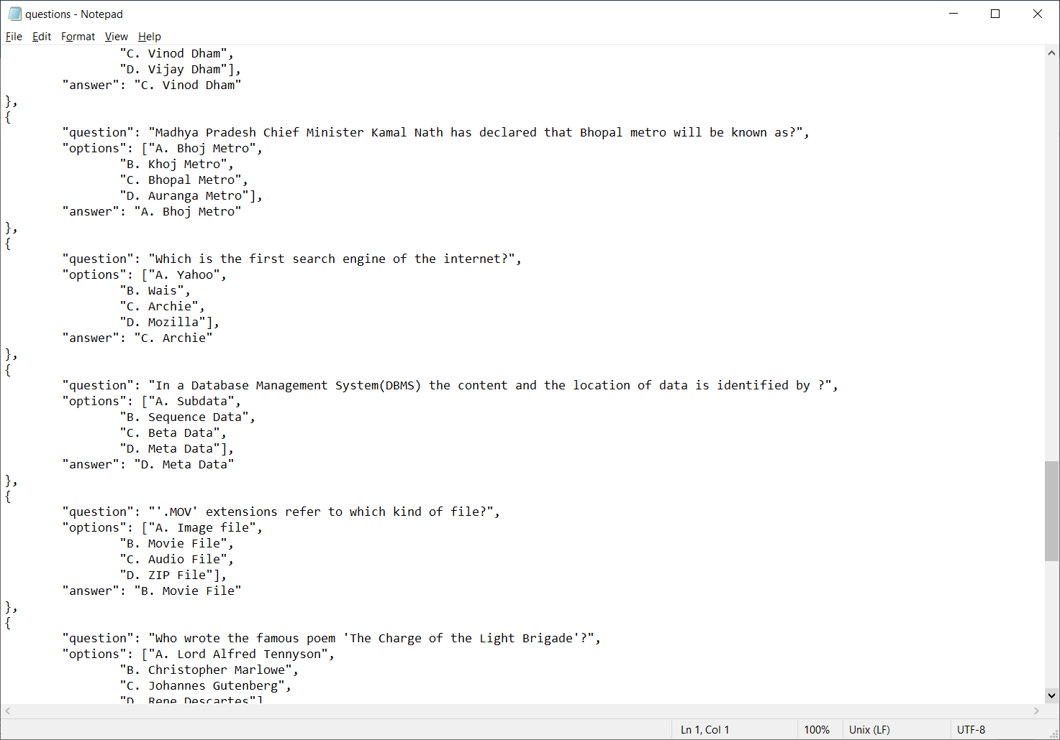

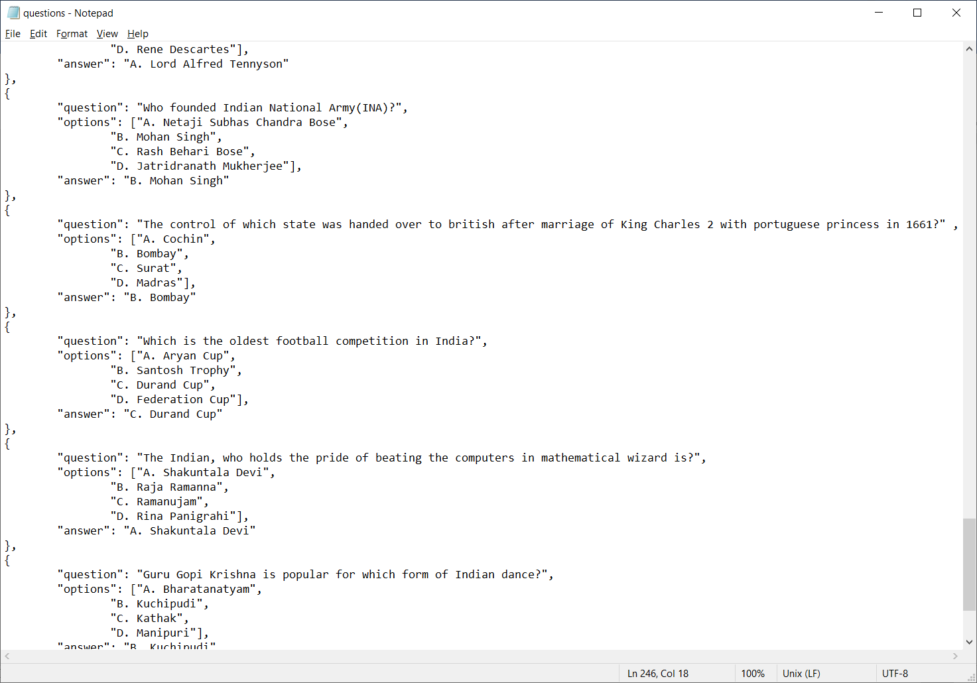

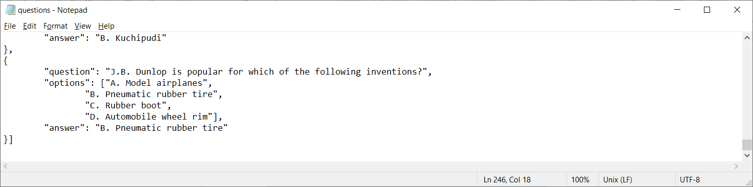

1. Input Screen

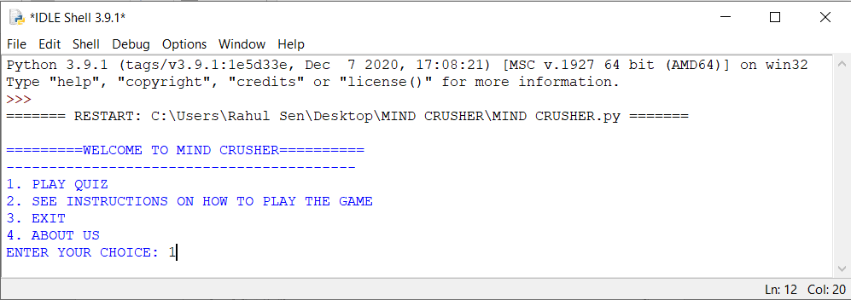

1. 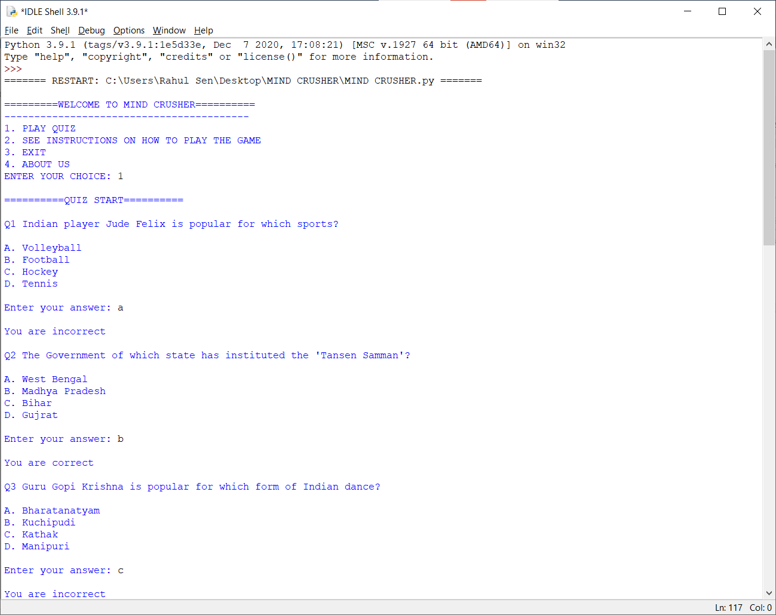Output Screen

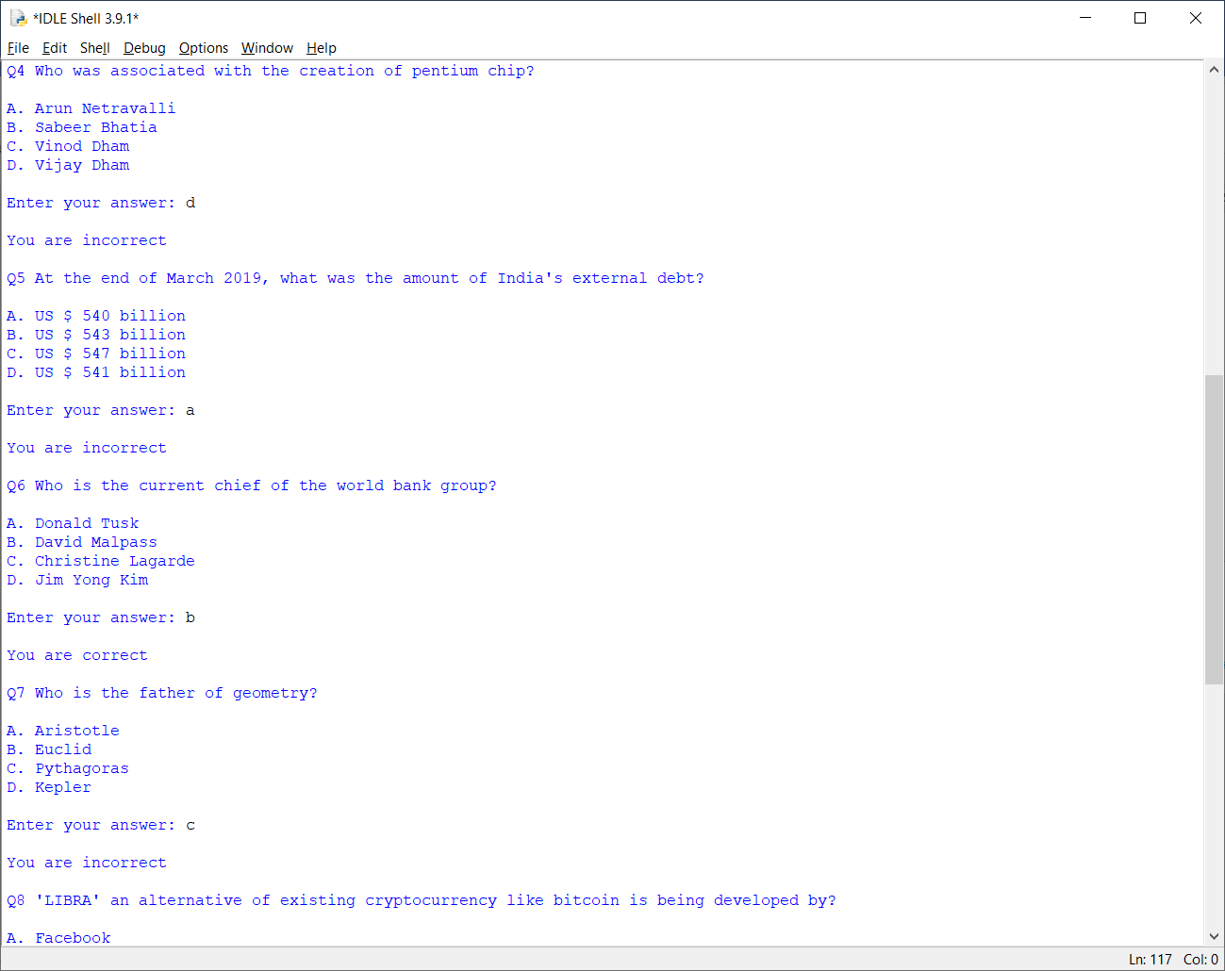

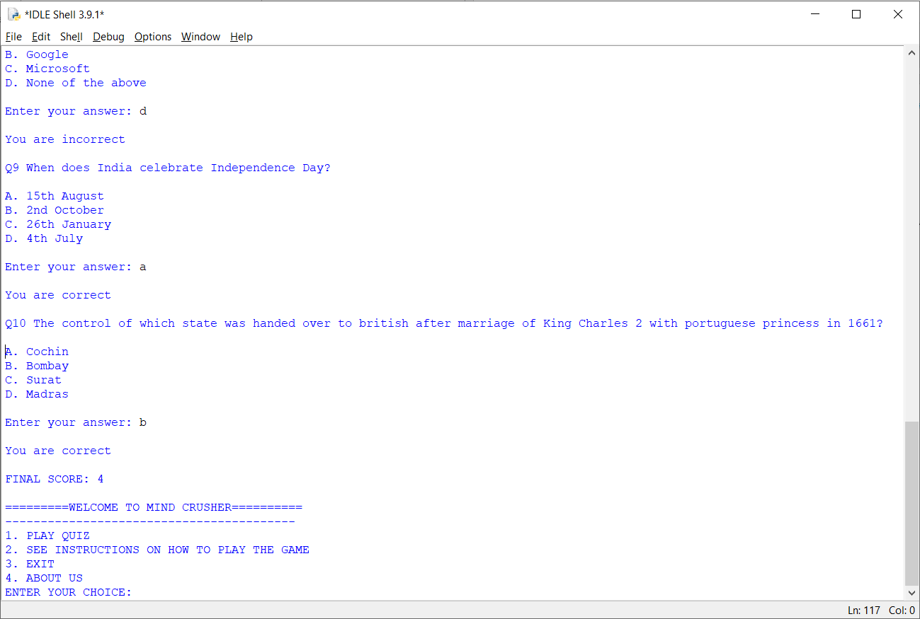

* <https://www.google.com>
* <https://stackoverflow.com>
* <https://docs.python.org/3/>
* <http://python.mykvs.in/uploads/showpapers/testproject.php/6/>
* <http://www.tutorialspoint.com/pythom>
* Computer Science with python by Sumita Arora (2020 EDITION)



